CAMDEN R.S.L SUB BRANCH
ANZAC DAY 2023 COMMEMORATION SERVICES

The Camden RSL Sub Branch will be conducting services to commemorate the Anniversary of the Landing at Gallipoli, on behalf of the President and Members of the Camden RSL Sub Branch we cordially invite you to attend ANY OR ALL of the services.

Services to be held:
Barry Marsh House - ANZAC Commemoration Service will be conducted in the Recreation Centre on Friday 21st April, 2023 commencing at 10.30am Everyone is welcome

Camden Downs Retirement Village - ANZAC Commemoration Service will be conducted in the Recreation Centre on Friday 21st April, 2023 commencing at 2.30 pm. Everyone is welcome

RSL LifeCare – 25 Estonian Rd, Thirlmere NSW 2572 -
Saturday 22nd April, 2023 commencing at 10.30am

Club Menangle at Menangle Raceway – will conduct a short ANZAC Tribute Service at approx. 6.30pm (time to be advised) on Saturday 22nd April, 2023

Carrington Centennial Care - ANZAC Day Service will be conducted in the Flagpole Area of Carrington on Monday 24th April, 2023 commencing at 10.30am. Everyone is welcome

Wivenhoe Retirement Village, 6 Hollyhock Avenue Cobbitty - Camden RSL Sub Branch Dawn Service will be conducted on Monday 24th April, 2023 commencing at 2.30pm

Camden RSL Sub Branch Dawn Service will be conducted on Tuesday 25th April, 2023 within the Camden Bicentennial Equestrian Park Memorial Site, Cawdor Road, CAMDEN NSW 2570, commencing at 5.15am sharp, Cawdor Road from Camden Sports Club to Barsden Street, will be closed from 4.45am until 7.00am. We request everyone to be seated by 5.00 am.
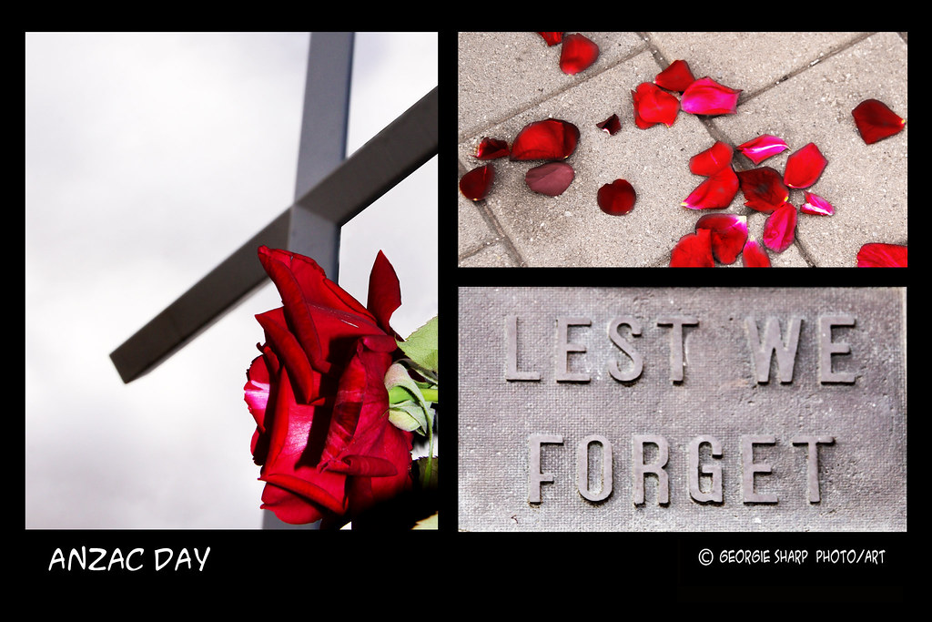

Main ANZAC Day March and Community Service
Marchers will assembly in Elizabeth Street between Mitchell and Elizabeth Streets from 10.00 am with the march commencing at 10.30am, marchers will move from Elizabeth Street, down Arygle Street, follow Cawdor Road to the Camden Bicentennial Equestrian ParkPark
Following the completion of the 2023 March into Camden Bicentennial Equestrian Park the 2023 Camden Anzac Day Commemoration Service commences at 11.15 am

Wreath Laying
Wreath laying is permitted from Schools, Companies, Organisations

We recommend Camden Florist – 02 46 55 8224

Community groups and Individuals during both services prior notice via email would be appreciated.

Any enquiries – Contact: Camden RSL Sub Branch Events Coordinator
Email: CamdenSB@gmail.com

